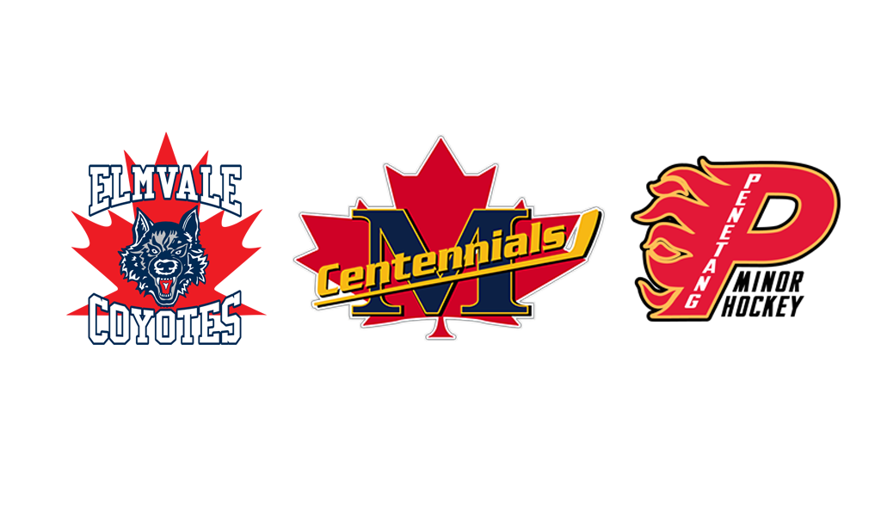

**Reorganization FAQ**

We would like to extend our sincere thanks to everyone for taking the time to learn about the opportunity our association and players have with joining Elmvale Minor Hockey, Midland Minor Hockey, and Penetang Minor Hockey in a hybrid (amalgamation) reorganization.

We kindly encourage you to review our FAQ document, which addresses key information about the hybrid (amalgamation) reorganization. This document offers valuable insights into the proposed reorganization, outlining its objectives and the anticipated benefits for players, coaches, and our members.

We would also like to encourage everyone to attend the information sessions that will be held prior to the reorganization vote. These sessions will provide an opportunity to ask questions and gather more information about the proposed changes.

**Why is it now called reorganization and not amalgamation?**

OMHA has reviewed the process of amalgamations and decided that calling it a reorganization is better suited to what our associations are proposing to do. Going forward we will be addressing this amalgamation as a reorganization.

**Why should we reorganize?**

1. **Enhanced Player Development:** By pooling resources, expertise, and facilities, combined centres can provide more comprehensive training programs, specialized coaching, and better developmental opportunities for competitive stream players.
2. **Higher Classification:** Combining smaller hockey centres into a larger organization enables players to compete at higher levels (A or AA) without the significant travel increase currently required for NRP or AAA players.
3. **Community Engagement:** Combining centres could help foster stronger community ties by bringing together a larger and more diverse group of participants, families, and supporters while maintaining our storied hockey histories within our local arenas and with the continued operation of our local league teams.
4. **Streamlined Administration:** Reorganization can simplify administrative processes by consolidating operations and reducing duplication of efforts in areas such as registration and scheduling.
5. **Long-Term Sustainability:** Combining resources and efforts can help ensure the long-term sustainability of hockey programs, making them more resilient to economic fluctuations and other challenges.

By addressing these factors, reorganization can create a stronger, more vibrant hockey community that benefits players, families, and the broader hockey ecosystem.

**What will the reorganization look like?**

A new not-for-profit organization will be created that will jointly administer the Representative hockey for the three active not-for-profit organizations who will continue to offer and administer their own Recreational (Local League) programming.

**What would the New OMHA Rep Centre look like?**

* Would be an A centre (consideration can be given to moving to a higher base category in the future based on the results of the association’s teams and registration numbers)
* 8 A teams: U10, U11, U12, U13, U14, U15, U16, U18 (note: U18 is a double year)
* Up to 4 BB/Second Entry Teams: U11, U13, U15, U18 (based on interest)
* Teams will be a minimum of 15 skaters and 2 goalies (unless approved by board to be smaller)
* Similar number of games currently scheduled and two on-ice practices per week
* New boundaries will be created later
* Play out of Elmvale Arena, North Simcoe Recreation Centre and Penetang Memorial Community Centre
  + Practice locations will be determined later based on needs of all three centres and ice availability striving for each team to practice in two of the three locations based on a consistent weekly schedule
  + Games will be scheduled for all three locations with consideration given for older teams to play more frequently on the larger ice surfaces and younger teams to play more frequently on the smaller ice surfaces.

**What would the Local League Centres look like?**

* Would house the U11, U13, U15, U18 and U21 teams
* Responsible for U5/U6, U7, U8 and U9 programming including U9 MD teams
* The number of teams will be determined by registration
* Same number of games currently scheduled and one on-ice practice per week
* There are no boundaries for local league teams
* Every effort will be made to harmonize the offerings and fees in the three local league associations
* Play out of Home Arena
  + Ice time will be determined later but will have equal priority as the new OMHA A Rep Centre

**What is the Pilot Project clause?**

The pilot project clause will be included in the new OMHA A Rep Centre’s bylaws and will mandate a comprehensive review after both the first and second years of the reorganization. Following each review, any mutually agreed-upon improvements can be made to the structure and approach to not only enhance the experience for our members but also ensure the long-term success of the association, fostering sustained excellence and development for years to come.

During the pilot project period, each association will have the option to notify the others of their intent to withdraw from the new organization and revert to their previous structure. The change would become effective at the conclusion of the current season in which this notification is given.

**How does the Executive Board work for all the centres?**

A new board will be made consisting of four members from each of the current Elmvale, Midland and Penetang Hockey Associations’ boards. There will be 12 positions on the new board including one president and two vice presidents. The president and vice president positions will be limited to one member per association ensuring equal representation from across the associations at these important positions.

Each association will have equal voting rights on all issues and will have equal representation on all subcommittees.

After 2 years, an independent board will be voted in by the membership. From that point on, the board will expand to include a Past President position bringing the number of board members/positions to 13.

The Local League associations will maintain their own boards, which will be responsible for managing their individual programs. While it is anticipated that each local league association may reduce the number of board members needed to fulfill their duties, the decision on adjustments will be left to each association's discretion.

**What are the start-up costs?**

Each home centre will provide funds in the form of an interest-free loan to aid new Rep Centres' initial setup costs.

* The start-up costs will be $60,000 with $20,000 paid by each association.
* 50% of the loan will be required to be paid back within the first two years of the reorganization.
* The remaining amount is required to be paid back within five years of the reorganization.

This collaborative financial assistance will help foster solidarity and unity among the three Home Centres, ensuring sustainable development and long-term success for the new OMHA A Rep Centre. However, it is important to note that this is a loan, and the local league associations will be fully repaid within five years.

**What will the new Association be called?**

If the vote is yes, a subcommittee of all the centres will be created to manage the new branding. All centres are very open to having the membership make recommendations which can be considered.

Due to the timing of the formation of the new organization, the naming of the association will occur first along with the creation of the new by-laws. This would then be followed by the naming of the team, selection of colour schemes (jerseys/socks), and logo creation at a later date.

**What are the new Association’s centrepoint and boundaries?**

The centrepoint for the new association will require OMHA approval. Therefore, the centrepoint and boundaries of the new OMHA A Rep Centre are not known at this time.

Our goal with selecting a **centrepoint** is to maintain similar boundaries and "Right of Choice" (ROC) areas for the players in our region, though some changes are bound to occur. We have internally discussed using Hillsdale or a similar location to the East of Elmvale and South-East of Midland to achieve this goal. We would work with the OMHA and neighboring associations to finalize the **centrepoint** and related boundaries after the voting is completed.

All players currently playing in Elmvale Minor Hockey Association, Midland Minor Hockey Association, and Penetang Minor Hockey Association will be eligible to play for the new Rep A centre through a grandfathering clause regardless of the **centrepoint** selected.

Once the **centrepoint** is approved, if you reside near two different hockey centre that are within 8km of each other, you may have the ROC to select which centre you wish to play for. After exercising this right and signing with the chosen organization, you will be considered a lifetime member.

**How will players be selected?**

All players who want to play at the new OMHA A Rep Centre will need to try out for the A team in their age group. If they do not make that team and there is a BB (Second Entry) team at their age group, they will have the opportunity to try out for that team. If they do not make a team at the OMHA A Rep Centre, they will play for their Home Centre’s Local League team. All Local League team players will be eligible to AP to the Rep Centre.

A comprehensive player selection process will be developed by the new association’s board through a dedicated subcommittee, with representation from all three associations. The player selection process will be a thorough and transparent system focusing on fairness, player development, and ensuring the best fit for team composition across the new OMHA A Rep Centre. No centre will be able to select players solely from their own centre. All teams will consist of players based on their skill levels rather than the centre they come from.

**How will coaches be selected?**

All coaches who want to coach at the new OMHA A Rep Centre will need to submit an application to coach the A or BB (Second Entry) team at a specific age group. A panel will interview the coaching candidates and submit their recommendations to the new association’s board for approval.

A comprehensive coach selection process will be developed by the new association’s board through a dedicated subcommittee, with representation from all three associations. Candidates will be evaluated based on their coaching experience, qualifications, and ability to foster a positive and competitive team environment, ensuring the best possible experience for both players and the broader hockey community. No centre will be able to select coaches solely from their own centre.

**How does a reorganization happen?**

On Wednesday, October 23, 2024, each association will hold a Voting Meeting for their respective organizations.

Members must be present at this meeting to vote.

If the vote is yes to reorganization from all associations, we aim for the reorganization to begin at the start of the 2025-2026 season, pending OMHA's approval.

If the vote is no for your respective Association, it will continue as it is now.

If the vote is no for 1 association and yes for the other 2, the proposed reorganization involving all 3 centres will not continue. *However, if they choose, the 2 centres that voted ‘Yes’ would have the opportunity to proceed with reorganization involving just the 2 centres.*

**How do we vote?**

On Wednesday, October 23, 2024, each association will host a Voting Meeting for their respective organizations. Voting will be open from 6:00pm until 9:00pm with members able to drop in and vote at any time during that window.

The results of the vote will be announced once all three centres have held their voting meeting.

All three centres will announce the voting results on Thursday, October 24th at noon on their own Minor Hockey websites. Any information you hear about the votes and/or their results before they are announced on the website will not be official.

**Who is eligible to vote?**

This varies by association based on each centre's bylaws. Please refer to your Association’s bylaws for a detailed statement on voting eligibility. The summary provided here is for reference only. If you have any questions regarding eligibility, please reach out to your centre’s contact listed at the end of this document.

*Elmvale Minor Hockey Association*

* All players rostered with the Association*; and
* All elected or appointed board members within the Association that do not qualify as parent/guardian members; and
* All rostered team officials within the Association including coaches, assistant coaches, trainers and managers that do not qualify as parent/guardian members;

*Midland Minor Hockey Association*

* All players rostered with the Association*; and
* All elected or appointed board members within the Association; and
* All team officials within the Association including coaches, assistant coaches, trainers and managers; and
* Lifetime members

*Penetang Minor Hockey Association*

* All players rostered with the Association*; and
* All players who are rostered with a AAA Association in the OMHA under AAA player movement regulations, and whose home centre remains the Association; and
* All players who are rostered with another Association in the OMHA under non-resident player (NRP) movement regulations, and whose home centre remains the Association; and
* All elected or appointed board members within the Association; and
* All rostered team officials within the Association including coaches, assistant coaches, trainers and managers.

**\*** - For rostered players under the age of 18, a parent/guardian will vote on their behalf. Should there be a disagreement between which parent/guardian will vote, the parent/guardian residing at the primary residence of the player will be deemed the eligible voter.

**What are the rules for quorum and majority?**

This varies by association according to each centre’s bylaws. Please refer to the bylaws for a detailed statement on quorum and majority. The summary provided here is for reference only.

|  | **EMHA** | **MMHA** | **PMHA** |
| --- | --- | --- | --- |
| **Quorum** | 50% | 9 members | No minimum |
| **Majority** | >= 66% | > 50% | > 50% |

**When are the Information Sessions?**

The three associations will be hosting in-person information sessions prior to the reorganization votes to address your questions. Please keep an eye on your respective association’s website for details on the dates and times of these sessions.

Each session will be held at one of the various centres, but you are welcome to attend any session that fits your schedule. The content will be consistent across all sessions.

* **Elmvale** - Thursday, October 17th at 7:00pm (Elmvale Community Hall)
* **Midland** - Thursday, October 10th at 7:00pm (NSSRC Community Hall)
* **Penetang** - Monday, October 7th at 7:00pm (PMCC Lounge)

**Additional Questions**

If you have any questions, please join one of the information sessions or reach out to your association’s main contact:

Elmvale Minor Hockey:

Ryen Oakes

[president@elmvaleminorhockey.ca](mailto:president@elmvaleminorhockey.ca)

Midland Minor Hockey:

Colleen Baker

[ctweedy.hockey@gmail.com](mailto:ctweedy.hockey@gmail.com)

Penetang Minor Hockey:

Duane Homick

[president@penetangflames.ca](mailto:president@penetangflames.ca)